Assessment: Lab Exercise 06

Student Name: Adam Di Cioccio

Lab Professor Name: Mohammad Patoary

Lab Section Number: 321

Due Date: November 13, 2020

# Order of operations

**42 / 3.0 + 44 >= 100 && true || 99 - (11*9) + 45 < 42**

= 42 / 3.0 + 44 >= 100 && true || 99 - 99 + 45 < 42

= 14 + 44 >= 100 && true || 99 - 99 + 45 < 42

= 58 >= 100 && true || 45 < 42

= false && true || false

= false || false

**= false**

**x++ + y > (y = 3) || 45 - y++ <= 2 x = 10, y = 5**

**=** x++ + y > (y = 3) || 45 - y++ <= 2

= 10++ + 5 > (y = 3) || 45 - 3++ <= 2

= 11 + 5 > 3 || 45 - 4 <= 2

= 16 > 3 || 41 <= 2

= true || false

**= true**

**! (3 + 5 > 7 && 42 == 5 || ! (3 <= 3))**

= ! (3 + 5 > 7 && 42 == 5 || ! (3 <= 3))

= ! (3 + 5 > 7 && 42 == 5 || ! true)

= ! (3 + 5 > 7 && 42 == 5 || false)

= ! (8 > 7 && 42 == 5 || false)

= ! (true && 42 == 5 || false)

= ! (true && false || false)

= ! (false || false)

= ! (false)

= true

# Java screen shot

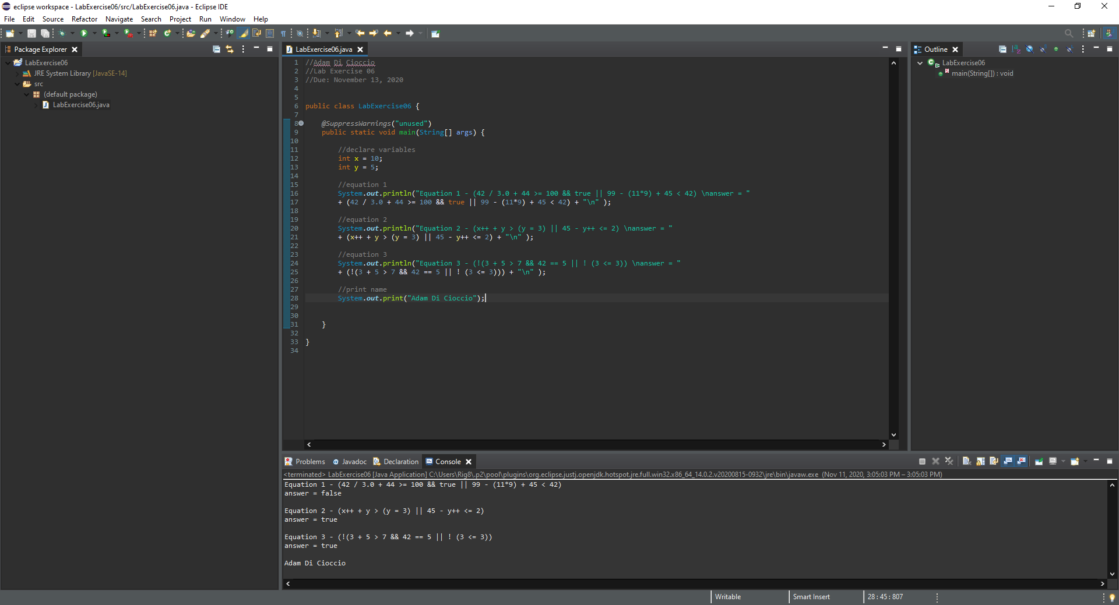

# Source Code for Program

//Adam Di Cioccio

//Lab Exercise 06

// Mohammad Patoary

//Due: November 13, 2020

public class LabExercise06 {

@SuppressWarnings("unused")

public static void main(String[] args) {

//declare variables

int x = 10;

int y = 5;

//equation 1

System.out.println("Equation 1 - (42 / 3.0 + 44 >= 100 && true || 99 - (11*9) + 45 < 42) \nanswer = "

+ (42 / 3.0 + 44 >= 100 && true || 99 - (11*9) + 45 < 42) + "\n" );

//equation 2

System.out.println("Equation 2 - (x++ + y > (y = 3) || 45 - y++ <= 2) - X = 10, Y = 5 \nanswer = "

+ (x++ + y > (y = 3) || 45 - y++ <= 2) + "\n" );

//equation 3

System.out.println("Equation 3 - (!(3 + 5 > 7 && 42 == 5 || ! (3 <= 3)) \nanswer = "

+ (!(3 + 5 > 7 && 42 == 5 || ! (3 <= 3))) + "\n" );

//print name

System.out.print("Adam Di Cioccio");

}

}

# References / Sources Cited